ECSE-200 Electric Circuits 1 - Quiz #7 (Mar. 1, 2019)

**LAST NAME** ______________________________________________ **MCGILL ID#** __________________

**FIRST NAME­­­­­­­­­**________________________________**SIGNATURE**_________________________________

* ***Only Faculty standard calculator accepted***
* ***No cellphone allowed***
* ***Show all your work***
* ***Clearly indicate your final answer with the SI unit and multiplier***
* ***You have 45 minutes to complete this quiz***

**__________________________________________________________________________________________**

**Question 1:** Consider the circuit shown below. Answer the following questions.

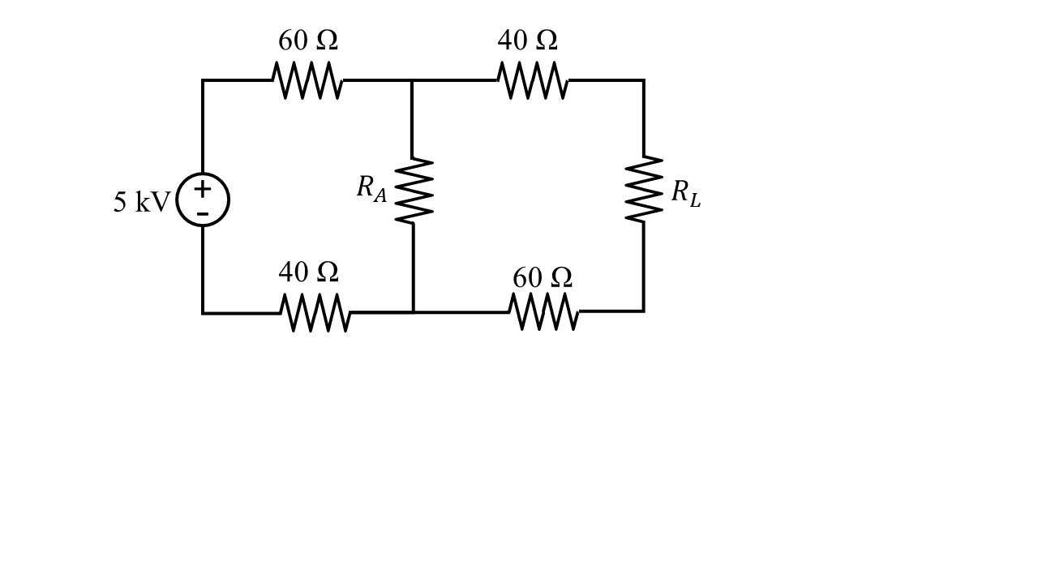

1. Under the condition where $R_{L}=0 Ω$, what resistance value should $R_{A}$ be to maximize the power delivered to $R_{A}$ and what is the maximum power value that can be delivered to $R_{A}$? [2 pt]
2. Under the condition where $1/{R_{A}}=0 Ω^{-1}$, what resistance value should $R_{L}$ be to maximize the power delivered to $R_{L}$ and what is the maximum power value that can be delivered to $R_{L}$? [2 pt]
3. Under the same condition where $1/{R_{A}}=0 Ω^{-1}$, but with the constraint that the current through $R_{L}$ must be at least 15 A, what resistance value should $R_{L}$ be to maximize the power delivered to $R_{L}$ and what is the maximum power value that can be delivered to $R_{L}$? [3 pt]

Extra Working Space

**Question 2**: Consider the circuit shown below. Assume an ideal op-amp behavior. Answer the following questions.

1. Under the condition where $I_{x}=0 A$, what is the voltage value $v_{0}$? [2 pt]
2. Under the condition where $I_{x}=1 A$, what is the current value $i_{0}$? [2 pt]
3. Under the condition where $I_{x}=2 A$, what is the current value $i_{G}$? [2 pt]
4. Under the same condition as in part c) where $I_{x}=2 A$, what is the power delivered by the current source? [1 pt]

Extra Working Space